
UNIVERSITY OF ENGINEERING AND TECHNOLOGY PESHAWAR, Jalozai CAMPUS
Lab 1: Python introduction, installation, and good practices
Lab Title: Introduction to AI programing
Date: Tuesday, September 30, 2025 Time: 3hrs
- Install IDE: Recommended ide python or anaconda.
  - Anaconda: https://www.anaconda.com/download
  - Python: https://www.python.org/downloads/
- Make a GitHub account.
  - https://github.com/
- Helping websites
The following are some of the website that will help in code development
  - Introduction to stack overflow: This is helpful for code debugging.
https://stackoverflow.com/
- Search the answer for most common programming questions.
- Search for error messages to see what cause them.
- Ask programming questions to get Answer from programmer worldwide.
- Gain valuable insights about programming in general.
  - Real python: A great, in depth, and to the point resources.
- https://realpython.com/
- https://www.youtube.com/@realpython
  - Geeks For Geeks
- https://www.geeksforgeeks.org/
  - W3School
- https://www.w3schools.com/CPP/default.asp
- Jupyter Notebook:
  - The following link will help in understanding of how to use jupyter notebook conveniently. This is like walk through video.
https://www.youtube.com/watch?v=HW29067qVWk&t=27s
- Virtual environments allow to manage Python projects, packages, and versions efficiently. Must make a virtual environment. For guid line how to make a virtual environment use the following YouTube link.
- https://www.youtube.com/watch?v=23aQdrS58e0&t=10s
- Use online code editor: Run your code online on google colab if python is not installed on your machine.
https://colab.google/
- Courses
- Complete the following two courses on coursera. Click on the following link.
https://www.coursera.org/specializations/python
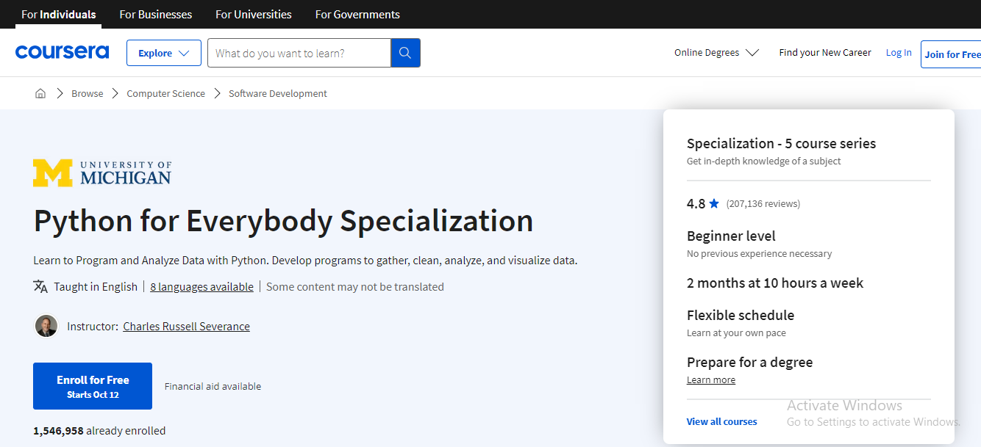
- Click on the enrolment.
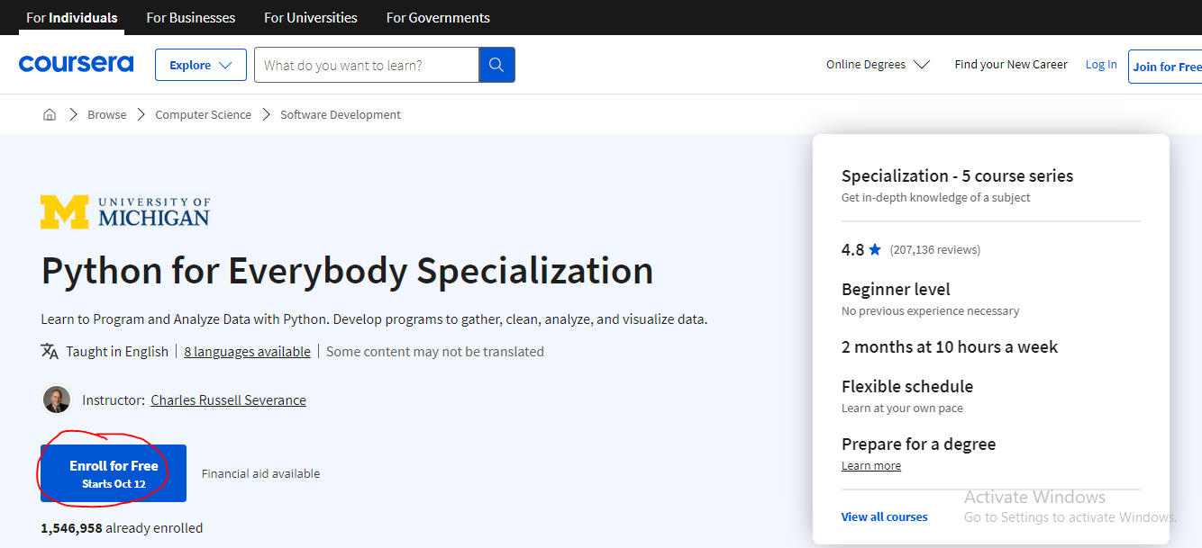

- Signup while using 2 in the following image or if you have account then use your email and password as mentioned in 1 below.
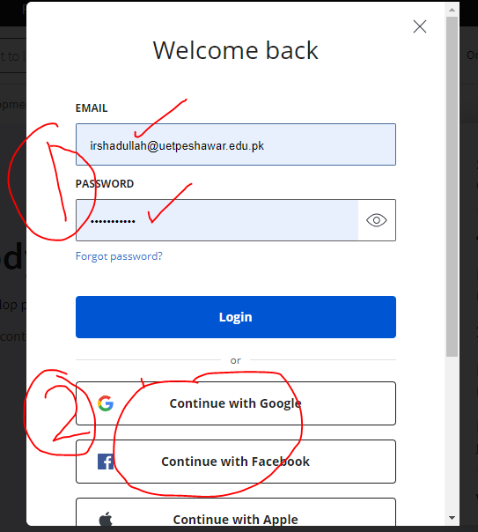
- The specialization has 5 courses. There are two courses that cover the basic you need that are c1 and c2.
Click on the small icon 2. This is a drop-down menu which includes detail.
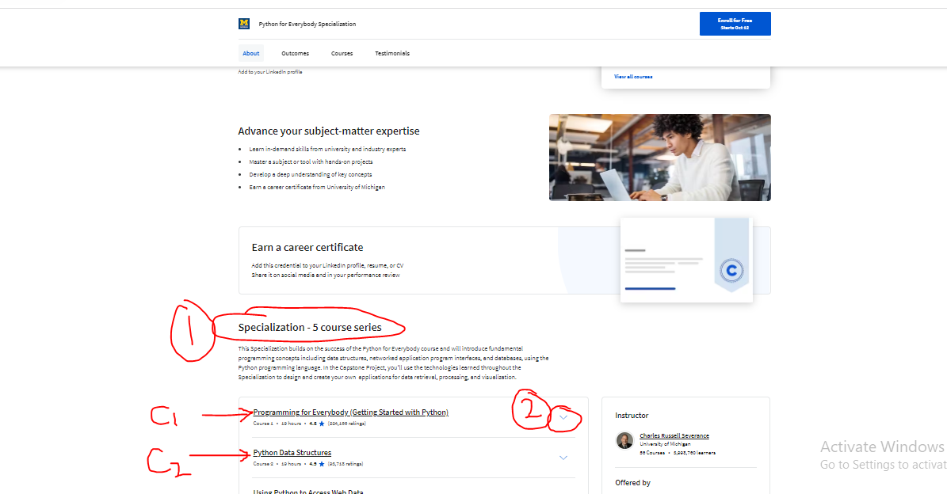

- The course detail are shown in the following image.
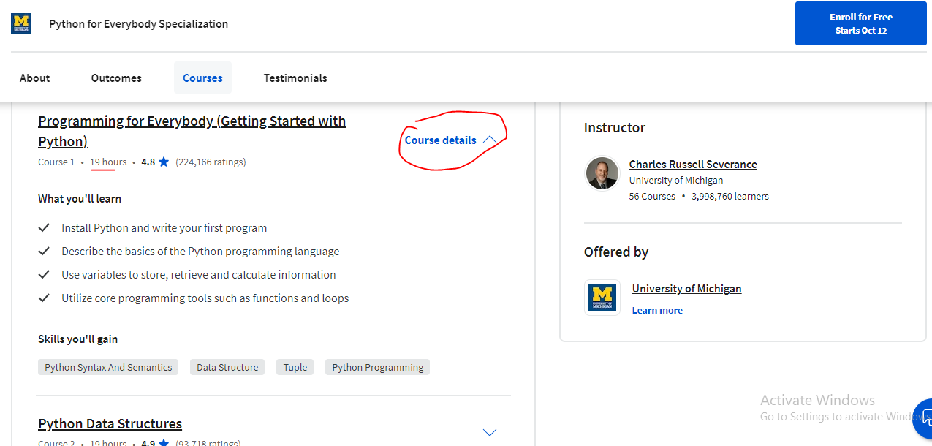

- Click on the course section. Click on the underline line.
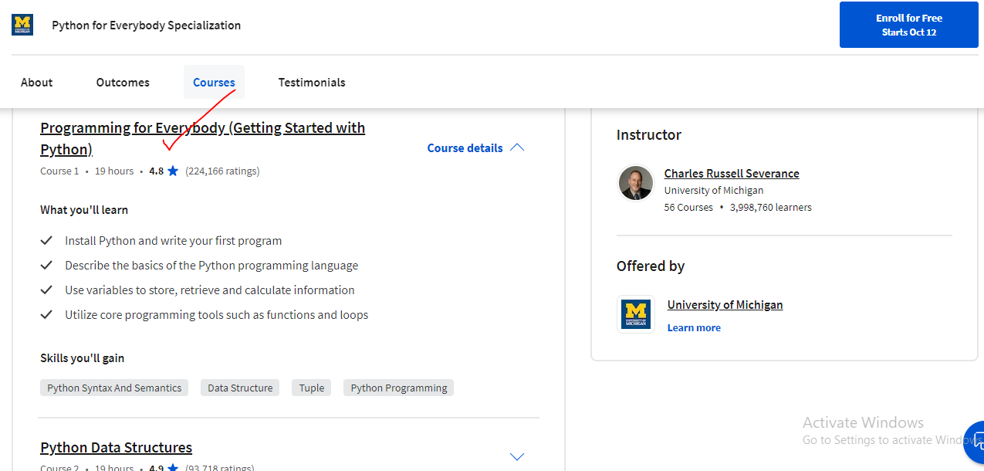
- The following course will be opened.
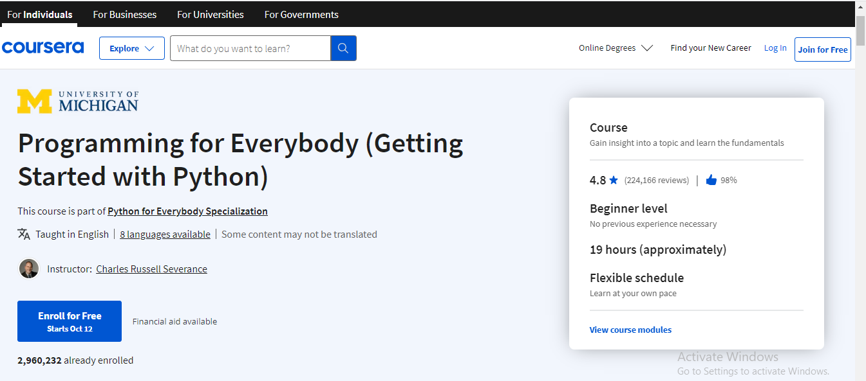

- Scroll down to the end.
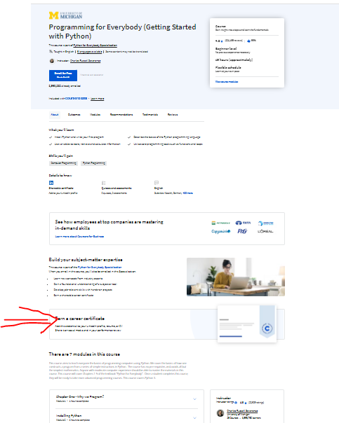

- Click on the video mark by 1 and contain 7 videos.
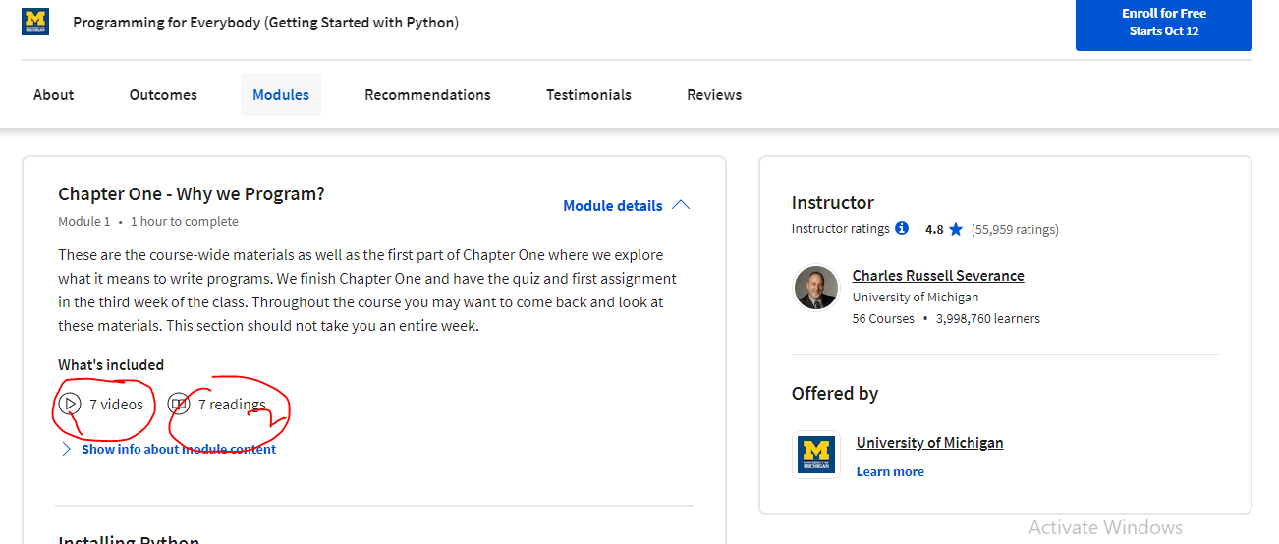

- The courses are available online on YouTube.
https://www.youtube.com/watch?v=UjeNA_JtXME&list=PLlRFEj9H3Oj7Bp8-DfGpfAfDBiblRfl5p
- Use the following GitHub link to copy any code of this book.
https://github.com/SyedHasnat/OOP-in-Python-UET/tree/main
Recommended books
- Python Tricks: The Book by Dan Bader
- How to think like a computer scientist by Allen Downey

